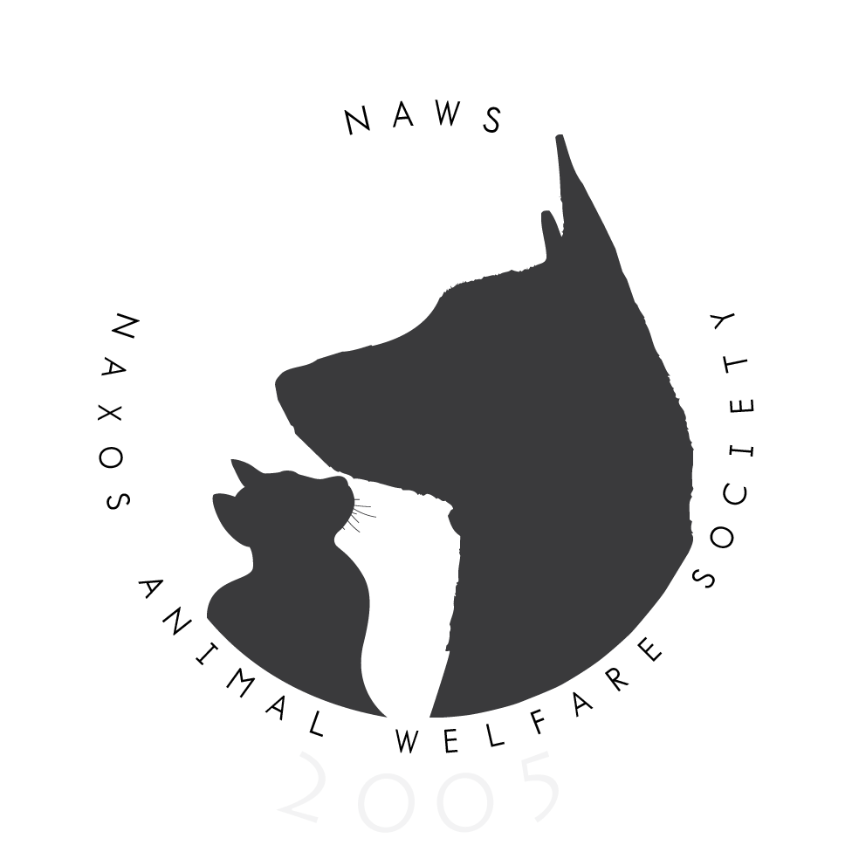

SYMPTOMS THAT AN ANIMAL HAS BEEN POISONED:

Insecticides – liquid or powder
Salivating at the mouth, excessive tears, diarrhea, twitching muscles, trembling, asthmatic breathing, convulsion and coma..
TREATMENT:
Take the animal to a vet as soon as possible.
To give the animal the best chance of survival administer first aid as follows:
1. Induce vomiting: give salt or baking soda dissolved in warm water into the mouth.
WARNING
Do not do this (1) if the animal shows signs of nervousness such as trembling, staggering or collapse because an emetic can cause inhalation pneumonia.
Continue to the next step (2).
2. Give an injection of atropine – 1 vial for a cat or small dog, 2 to 3 vials for larger dogs – injected into the vein (absorbed most quickly), into the muscle (absorbed less quickly) or under the skin (slowest absorption). Atropine can be obtained from your vet.

Rat poison
Sometimes there will be no symptoms for 2 or 3 days. Then red/purple/dark blue patches will appear on the body or gums, a sign of internal bleeding, and the gums will be very pale in colour, rat poison damages the clotting mechanism and the animal can haemorrhage from the nose, mouth, penis, vagina or rectum as well as internally.
TREATMENT:
Konakion (vitamin K) injection to help clot the blood, 5-20mg, depending on the size and weight of the animal.
Ground Glass
This is the deadliest of all methods and there is no antidote. It is essential, however, to get the animal to a vet as soon as possible to try and save its life.
IMPORTANT:
An animal that has been poisoned with insecticides or ground glass is very sensitive to light and
noise so protect it from both; this is not the case with rat poison. However, you may not be aware
of the poison used so always keep the animal covered and as quiet as possible when transporting
it to the vet.

BE PREPARED!
Carry a first aid kit with you: bottled water, package of salt, atropine and syringes and a copy of this information. Talk to your vet about how to administer first aid and what amounts to give. It can save an animal’s life.

